34th Annual Decorator Show House
16449 Ed Warfield Rd
Woodbine, Md 21797
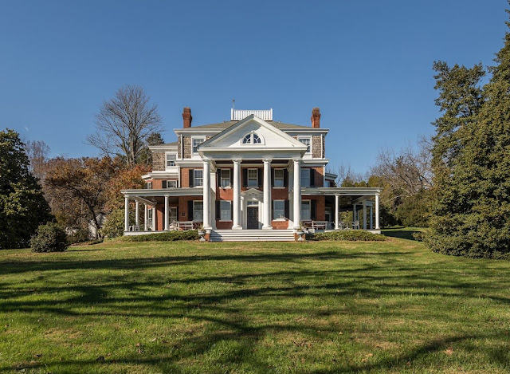

Information for
Show House Designers

Contents

- Timeline
- Floor Plan
- Spaces Available to be Decorated
- Design Guidelines
- Instructions for Submitting Proposals
- Design Board Format
- Designer Contract
- Additional Information/Contact email & Phone for HEC Show House

FLOOR PLAN
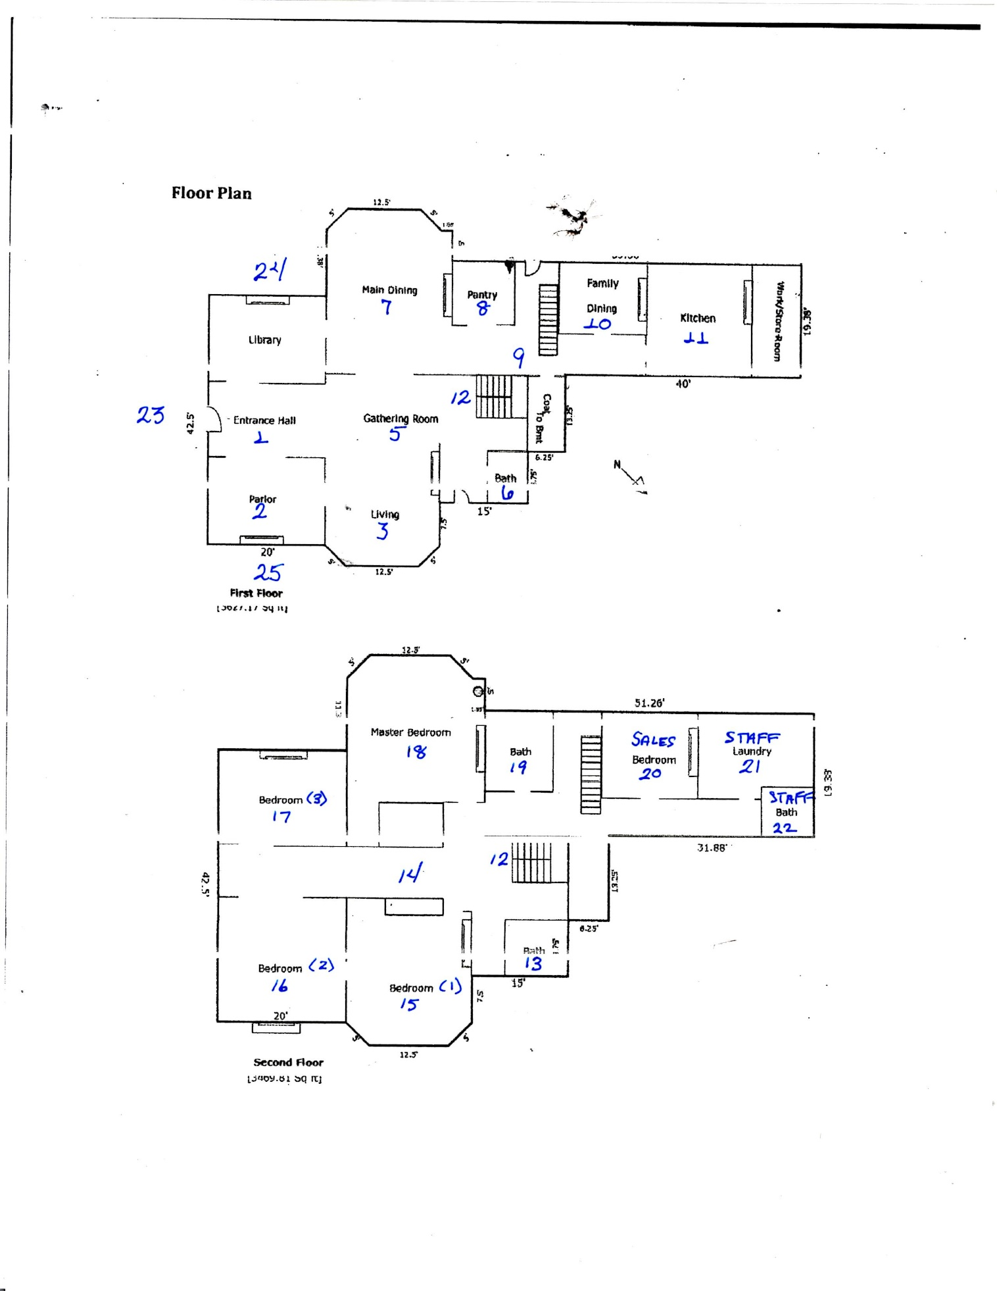
AVAILABLE ROOMS

- Entrance Hall
- Parlor (Reception)
- Living Room
- Library
- Gathering Room
- 1st Floor Entry Bath
- Main Dining Room
- Pantry (Staff Room)
- 1st floor Hallway
- Family Dining Room
- Kitchen
- Grand Stairway to the 2nd Floor

2nd Floor

- 2nd floor Hallway Front Bath
- 2nd Floor Hallway
- Bedroom 1
- Bedroom 2
- Bedroom 3
- Master Bedroom
- Ensuite Bath
- Sales Office
- Laundry (Staff Only)
- 2nd Floor hallway Back Bath (For Staff Only)
Porches:
- Front Porch
- Side Porch Left
- Side Porch Right
New Addition:
- Boutique
- Garden Café
- Antiques
- Special Projects Room
- Pool Area

Timeline

Date | Event/Action | HEC Lead
Jan 17 | Formal Invitation to the walk-through for Designers | Design Committee
Jan 29&30  Feb 5&6 | Designer Walk throughs: 12:00-4:30  Saturday 29 January and Sunday 30 January  Saturday 5 February and Sunday 6 February | Design Committee
Wed Feb 16 | Proposals Due via on-line submission from Designers: submit on our web site www.historicec.com | Web/Design Committee
Thu Feb 17 | Design Committee Reviews Proposals | Design Committee
Mon Feb 21 | Designers Notified of Decisions and are awarded their rooms | Design Committee
Thu Mar 3 | Designer Boards/Digital Boards. Due no later than March 3rd, boards can be delivered earlier to Peggy Maxson, 3779 Old Columbia Pike Ellicott City, Md. 21043. Digital Boards should be sent to showhouse@historicec.com | Design Committee
Fri Mar 4 | Boards Reviewed by the Design Committee
Sat Mar 5 | Design Boards Shown to Owners | Design Committee
Sat Mar 12 | Mandatory Designer Meeting at Show House, Designer Signed Contracts and Insurance Forms Due; Designers take additional measurements; Saturday, March 12 | Design Committee
Sat, Mar 12 | Dirty Work Begins | Design Committee
Sun, April 17 | Easter!! Show House Closed
Sun April 24 | Dirty Work Ends – Inspected by Design Committee | Design Committee
Mon April 25-Mon May 2 | Large furniture must be installed | Design Committee
Mon May 2 – Sat May 7 | All other furnishings, draperies and accessories installed/brought in | Design Committee
Sat May 7 | Designer Inventories, Requested Narratives, Lighting Instructions and Profiles Due: Sent to Showhouse@historicec.com | Design Committee
Sat May 7 | Last Day that Designers are allowed into the house until opening | Design Committee
Sun-Thu 8-12 May | Grounds Planning (parking lot laid out – Party prelaunch) | Design Committee
Thu 12 May | Preview Festivity | Catering Committee
Sat 14 May | Show House Opens to the public | All
Sat 14 May-Sun 5 June | Show House is open Thursday-Saturdays 10:00-5:00;  Sunday’s 12:00-4:00
Sun, 5 June | Last Day the Show House is open to the Public. The House is closed at 5:00 PM Immediately following is a Wrap Party for all the volunteers and Designers | All
Mon-Wed 6,7,8 June | Designers Bag and Tag Merchandise remove all Furnishings | Design Committee
Th-Sat 9-11 June | Customers Pick Up Merchandise | Design Committee
Sun-Wed 12-15 June | Designers do Final Touch ups – fill holes etc. | Design Committee
Sat 18 June | Final inspection House Returned to the Owner | Design Committee

Use this Space for your Notes
with Room or Area #’s/Name of Space to be Decorated

Design Guidelines
HEC will arrange to provide all the paint necessary for those who choose to paint the rooms. Should the designers choose, they can use the existing wall color, and no painting would be necessary. The designer may be asked to repaint the room back to the original color at the designer’s expense.

Designers may not paint any existing woodwork and trim, columns (including doors, windows, ceiling medallions, or moldings without the consent of the Owner.

During any “dirty work,” designers must protect the floors at all times, using rosin paper and tape or its equivalent provided by HEC, Inc. Designers must tape and tape paper-to-paper. Do not use tape directly on any floors.

Do not paint any non-painted surfaces such as bricks, hearths, fireplaces or floors, including hearth surrounds, unless permission is sought and approved by HEC and the Owner.

Designers may use non-textural faux finishes, stencils or murals. Designers must insure that the walls will not be permanently damaged by any treatment used.

Designers cannot use wallpaper unless it is removable. In which case the designer would be responsible for any repair and repainting of the wall if required to be removed after the Show House by the Owner.

Designers cannot use any new molding(s).

ONLY the professional show house electrician can install or remove ALL electrical fixtures. Designers must label and store, in an HEC, Inc. designated space, all lighting and other materials removed from their room.

HEC, Inc. reserves the right to remove doors from design areas as necessary.

If HEC, Inc. asks the Designers to remove doors to allow proper flow of traffic, the Designers must label all doors and hardware and attach the removed hardware to the door before storage in an HEC, Inc. designated area.

Designers, their painters, faux finishers, etc., may not clean brushes and supplies on the show house premises. They also must park in designated areas.

Absolutely no sinks or bathrooms may be used for cleaning brushes.

Please do not disturb the general architecture. Any design issues or questions about aforementioned items must be discussed with and approved by Design Committee.
Guide to Submit Room Proposals
DUE DATE: Saturday February 16, 2022

An on-line form to submit a proposed design description for each room that you are considering and will be available on our website: www.historicec.com.

Designers will be asked for the following information:
Designer Name and Company Name & Address, E-Mail & Phone numbers
Preferred method of communication (email, text or phone call)
A description of your proposed design for each room. You must choose three rooms, indicating a first choice, second and third. You should be prepared to describe your design concept, a color scheme, specific furniture you are considering and a description of your vision. If you do not submit three choices, you will not be eligible for participation. Each description must be a minimum of 120 words.

Proposals will be reviewed en masse by our Design Committee. After selections are made designers will be notified and given two weeks to submit a design board (specifications for the design board are also outlined in this packet).

The design board is reviewed by the Committee, and then shown and reviewed by the Owner. Upon completion of this process, the designer is given the approval to move forward.

Design Board Format
DUE DATE: no later than Thursday, March 3, 2022

Size: Presentation Boards shall be no smaller than 20”x30” and no larger than
24”x 36”. More than one board may be submitted.

Due Date: Thursday, March 3, 2022
The Design Committee will review the selections and present them for the owners’ review.

Content: Design boards must include:
- A one–quarter inch scale floor plan. (Please consider traffic flow through the room.)
- Photos of furniture; renderings or photos of window treatments and lighting fixtures.
- Samples of fabrics, floor coverings, and wallpaper.
- Wall and Ceiling paint colors; trim colors if allowed; and the particular finish of the paint. Please include the name of the colors, manufacturer, and manufacturer number.
- Exact samples of faux finishes, stenciling or decorative wall paintings. Also, location and size of stencil or decorative wall paintings.

Changes: Present any/all changes to your design boards in writing to the Design Committee Chair.

Please state the reason for the change and include samples, photographs, or renderings, as necessary. The Design Committee must approve any and all changes.

IMPORTANT: Put your room number and name and all of your contact information on your board. You should bring your Board to Peggy Maxson’s House at 3779 Old Columbia Pike, Ellicott City, 21043. Text to 443-474-7999 prior to dropping off. There will be a box on the porch that you can drop off your board if she’s not home.

DECORATOR CONTRACT

This shall constitute an Agreement between ______________, hereinafter referred to as “Decorator” and Historic Ellicott City, Inc., hereinafter referred to as “HEC”, a charitable non-profit Maryland Corporation.

WHEREAS, HEC desires to hold a charitable fundraising event, to be known and advertised as “The 2022 Decorator Show House” and to take place at Oakdale located at 16449 Ed Warfield Rd, Woodbine Md (hereinafter referred to as the “Show House”); and

WHEREAS, the undersigned Decorator wishes to participate in the 2022 Decorator Show House subject to the terms and conditions set forth herein;

NOW, THEREFORE, in consideration of the premises and of the mutual promises and agreements set forth herein, the parties agree:

RESPONSIBILITY OF DECORATOR

The Decorator will decorate in a professional and workmanlike manner at its sole expense, a room, AS IS, or other portion of the Show House, AS IS. The room or other area for which the Decorator shall be responsible shall be assigned by HEC, after submittal of a design proposal.

The walls, floors and other parts of the Show House shall not be altered, penetrated, damaged, defaced or modified in any manner without permission of HEC and the Owner. Any fixture removed from the room or assigned portion of the Show House must be labeled with the name of the Decorator, stored in an area designated by HEC, and returned and reinstalled in its original location promptly upon closure of the Show House event.

At the close of the Show House event, any damage to that part of the premises occupied by the Decorator, or any other damage done by the Decorator, shall be repaired by the Decorator at his or her own expense.

The Decorator shall not paint any marble or stone mantels, fireplaces, floors, hardwood floors, stair hand railings, doors, shutters, brick or tile without first obtaining permission of HEC and Owner. Painting over existing wallpaper is not permitted without express permission of HEC. Painted doors, windows and trim must be repainted in a color approved by HEC. Any natural doors, windows and trim must remain natural, unless specifically approved to the contrary by HEC and Owner, in which event all previously unpainted wood must be primed before a finish coat can be applied.

The halls, both upstairs and down, must be coordinated between the respective decorators to present a compatible relationship. Any door to be removed from a room must be painted to match the room before removed, and no door or shutter shall be removed without the consent of HEC and Owner. Area rugs can be used throughout; however, wall-to-wall carpet installation is not generally acceptable and must be approved by HEC and Owner prior to installation. Flat paints are to be used on walls and semi-gloss paints on trim. Plumbing and electrical fixtures may not be removed without specific approval of HEC and Owner, and if removed, must be replaced unless agreed to the contrary by HEC and Owner.

TIME SCHEDULE

The Show House will be available to the Decorator for inspection and measurements only upon special appointment and must be coordinated with HEC. The Show House will be available to start painting, and other decorating beginning Saturday March 19, 2022, and such dirty work must be completed by Sunday April 24, 2022. The Show House will be available to start placing furniture and other furnishings therein on Monday April 25, 2022 and the delivery of those items must be coordinated with HEC. The Decorator’s work and operation of activities at the Show House shall be subject to such other rules, regulations and/or guidelines as may be established by HEC and communicated to the Decorator from time to time.

Not later than Thursday, March 3, 2022, the Decorator must submit to HEC a color board, having a size of no smaller than 20” by 30” and no larger than 24” x 36” indicating swatches of material and paint colors, and a ¼” scale floor plan of the room or other area identifying the furniture and furnishings and the proposed room design. This board will be delivered to Peggy Maxson at 3779 Old Columbia Pike, Ellicott City, Md 21043. While a physical board is preferred – digital boards will also be accepted – these should be sent to showhouse@historicec.com but must contain a floor plan and digital renderings of everything cited for the physical board. The Decorator shall not make any changes, modifications or alterations to the design as approved by HEC unless those changes, modifications or alterations are approved by HEC. In the event any of the Decorator’s work is not in strict accordance with the design as approved by HEC, the Decorator shall, following notice by HEC, immediately correct and/ or repair the Decorator’s work so as to comply with the design as approved by HEC.

Not later than Saturday May 7, 2022, the Decorator must submit to HEC a complete inventory and price list of all furnishings and items for sale in the Decorator’s assigned room or area. All items not for sale shall be so designated. The list shall be entered into an Excel spreadsheet provided by HEC for display in the Decorator’s room. HEC will produce sufficient copies of the inventory.

All decorating of the Decorator’s assigned room or area must be completed by 5:00 PM on Saturday, May 7, 2022. HEC will not permit un-inventoried items to remain in Decorator’s room. Decorator shall be bound by the price list submitted to HEC and HEC shall have the absolute right to offer any such item for sale at the inventoried price.

The Show House will open to the public starting Saturday, 14 May 2022 and continuing through Sunday, June 5, 2022, and thereafter all designer required repairs and removal of furniture absolutely must be completed by 4:00 PM, Wednesday June 15, 2022 , unless permitted by the Design Committee to finish removal by 4:00 Saturday,18 June 2022. Owner will not permit furniture to remain beyond that date and any remaining furniture will be removed and stored at Decorator’s expense. Any required repairs not completed by Saturday, June 18, 2022 will be contracted for by HEC at Decorator’s expense.

SALE OF FURNISHINGS

Sale of furnishings used by the Decorator in the Show House shall be handled by HEC solely. No items shall be removed until the end of the show house. HEC shall be entitled to fifteen percent (15%) of the price of each item sold in the Show House; furnishings shall not be “marked up” to a price higher than normally utilized in Decorator’s retail outlet. HEC has agreed to allow the Owner to purchase certain of the amenities prior to the Show House being opened to the public; however, any negotiations with Owner must be arranged through HEC’s Designated Representative.

INSURANCE AND INDEMNITY

The Decorator shall carry adequate fire, theft, and such other insurance as deemed appropriate by Decorator to insure fully against loss or damage of furnishings provided by the Decorator and HEC and Owner shall have no liability to Decorator for any loss or damage to furnishings or other property of Decorator. The Decorator shall indemnify and save harmless HEC and Owner against all claims, losses and expenses arising in any manner whatsoever for its performance of this Agreement. HEC shall carry liability insurance to cover its responsibility in connection with the Show House.

RESPONSIBILITY OF HEC

HEC shall manage and coordinate the Show House event, handle all publicity, provide staff and sales assistance when the Show House is open to the public.

TERMINATION OF AGREEMENT

If the Show House shall be damaged by fire or other hazard, or if for any reason HEC’s agreement to use of the Show House premises is terminated, this Agreement may be terminated upon notice to the Decorator by HEC without further liability. Furthermore, if the Decorator fails to perform this Agreement or to decorate a given room or other portion of the Show House in a timely and competent manner, this Agreement may be terminated upon notice to the Decorator by HEC without further liability to HEC. In the event of termination due to Decorator’s non-performance, HEC shall have the right to obtain a replacement and Decorator shall be liable to HEC for any expense incurred in the obtaining of a replacement decorator or completing Decorator’s responsibility hereunder.

MISCELLANEOUS

The Decorator and its suppliers or others working under its direction shall not park on the grounds except upon parking areas designated by HEC and/or the Owner.

If the Decorator uses fresh flowers or plants, Decorator will be responsible for their maintenance and replacement. Such maintenance should be carried out between 9 AM-9:30 AM. Decorator shall check the decorated area not less often than weekly to maintain the appearance of the decorated area in a professional manner.

Only colored water may be used in decorative accessories requiring the effect of coffee, tea, or wine. No combustible materials, fresh fruit, or food of any kind can be used in the Show House.

Any instructions to HEC with regard to lamps to be turned on, or other display procedures, shall be furnished to HEC via email by May 7, 2022 at 5:00 PM.

HEC reserves the right to designate an official photographer. Arrangements for photographing the Show House by other photographers must be approved by HEC in advance.

The Decorator shall perform its obligations hereunder solely as an independent contractor, and shall carry its own workmen’s compensation insurance, unemployment insurance and any other insurance necessary or required by law and shall provide HEC and Owner with a certificate of insurance verifying the existence thereof.

The Decorator agrees to comply with all ordinances, statutes or laws applicable to it. All work performed pursuant to this Agreement must be in conformity with the color board and room design approved by HEC and shall be performed in a professional and workmanlike manner.

The Decorator hereby agrees to indemnify and save HEC and Owner harmless against all claims, losses and expenses arising in any manner whatsoever from its performance of this Agreement, and waives any rights to any insurance covering or insuring HEC or Owner. HEC and Owner have not inspected the Show House (including the buildings, structures and surrounding property) for the presence of defects, hazardous substances (including but not limited to asbestos, lead paint, toxic materials), or dangerous conditions or materials. HEC and Owner disclaim all responsibility for any such defects, substances, conditions or materials and deny any and all liability for any injury or loss resulting therefrom. The Decorator accepts the premises “AS IS” and releases HEC and Owner from any and all liability to every agent, servant and employee of the Decorator for any such injury or loss.

The Decorator understands that there may be specific limitations or restrictions applicable to the decorating area. HEC shall provide to Decorator within 15 days following execution of this Contract any detail concerning specific limitations or restrictions applicable to the area subject to this Agreement.

Anything contained herein to the contrary notwithstanding, HEC reserves the absolute right in its sole discretion to require the removal of any item placed in any Design Area deemed by HEC to be inappropriate, which item, following receipt of a written notice to remove, shall be removed prior to the scheduled public opening. In the event said item is not timely removed, Decorator by the execution hereof authorizes HEC to remove and store said item at Decorator’s risk and expense.

HEC’s representative for notices and other communications hereunder will be provided to Decorator at the time of the scheduled Decorator Walkthrough.

To indicate your acceptance of the Decorator Contract, please sign one copy and return to HEC’s designated representative on Saturday March 12, 2022, during the Scheduled Mandatory Designers’ Meeting for acceptance by HEC.

If you have any questions, please call Connie Siegel at 410-461-6908 or Peggy Maxson at 443-474-7999

________________________________

Decorator Signature

________________________________

Decorator Name (please print)

_________________________________

Firm Name

_________________________________

Address

_________________________________

_________________________________

Business Phone

_________________________________

Cell Phone

_________________________________

Fax Number

_________________________________

E-Mail Address

ACCEPTANCE OF DECORATOR PROPOSAL

The Within Decorators Contract is hereby accepted this ___ day of _______, 2022
HISTORIC ELLICOTT CITY, INC., a non-profit Maryland corporation
By: ___________________________
Name: _________________________
Title: __________________________

Additional Information

- The Show House will be open to the public from Saturday 14 May to Sunday 5 June 2022.
- If you have a website, please add a link from your website to ours to help publicize the Show House. Our website is www.historicec.com.

- Contacts:
Connie Siegel, Show House CoChair, showhouse@historicec.com, 410-461-6908
Joan Becker, Show House CoChair, jmbbecker@aol.com Ph: 443-506-9454
Peggy Maxson, Design Committee Chair, showhouse@historicec.com, 443-474-7999

